**Test Case 0043 (part 1)**

**System:** VirtuCardsClient & VirtuCardsHost

**Description:** test that verifies if users can search for their friends.

**Severity:** 3

**Instructions**

1. Start VirtuCardClient application (or VirtuCardHost)
2. Click the button labeled “Sign In”
3. Enter “virtucards01@gmail.com” into the text input labeled “Enter email…”
4. Enter “Testing1” into the text input labeled “Enter password…”
5. Press the button labeled “Login”
6. A window should appear saying “Login Success”
7. Press the OK button that appears on that window
8. Press the friend’s icon on the bottom left
9. Press the search icon on the top right
10. Type “gamer1” in the search bar
11. Press search

**Expected Result:** since there is a user named “gamer1” already registered in VirtuCards, the user will be able to search the other play in the search bar and have the option to add them as a friend. Under the add option, the user can view the potential friend’s statistics on their gameplay.



This picture shows that the user as searched for someone and has the option to add and is able to see the player’s stats

**Test Case 0043 (part 2)**

**System:** VirtuCardsClient & VirtuCardsHost

**Description:** test that verifies if users can search for their friends.

**Severity:** 3

**Instructions**

1. Start VirtuCardClient application (or VirtuCardHost)
2. Click the button labeled “Sign In”
3. Enter “virtucards01@gmail.com” into the text input labeled “Enter email…”
4. Enter “Testing1” into the text input labeled “Enter password…”
5. Press the button labeled “Login”
6. A window should appear saying “Login Success”
7. Press the OK button that appears on that window
8. Press the friend’s icon on the bottom left
9. Press the search icon on the top right
10. Type “TestCase0001” in the search bar
11. Press search

**Expected Result:** the player is able to search for the player, but will not get an option to add the player because TestCase0001 is the username of the [virtucards01@gmail.com](mailto:virtucards01@gmail.com). The user is also given a message that says “You cannot add yourself” to remind them they are supposed to add people that are not themselves.

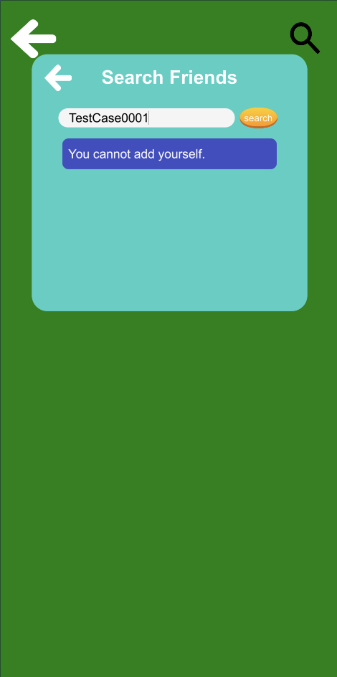

**Test Case 0043 (part 3)**

**System:** VirtuCardsClient & VirtuCardsHost

**Description:** test that verifies if users can search for their friends.

**Severity:** 3

**Instructions**

1. Start VirtuCardClient application (or VirtuCardHost)
2. Click the button labeled “Sign In”
3. Enter “virtucards01@gmail.com” into the text input labeled “Enter email…”
4. Enter “Testing1” into the text input labeled “Enter password…”
5. Press the button labeled “Login”
6. A window should appear saying “Login Success”
7. Press the OK button that appears on that window
8. Press the friend’s icon on the bottom left
9. Press the search icon on the top right
10. Type “lasdfjlsadk” in the search bar
11. Press search

**Expected Result:** when the user searches for player “lasdfjlsadk”, they are given a message that they are not able to add this person as a friend because they do not exist in the VirtuCards Firebase. They will also not get the option to add this person as a friend.



**Test Case 0043 (part 4)**

**System:** VirtuCardsClient & VirtuCardsHost

**Description:** test that verifies if users can search for their friends.

**Severity:** 3

**Instructions**

1. Start VirtuCardClient application (or VirtuCardHost)
2. Click the button labeled “Sign In”
3. Enter “virtucards01@gmail.com” into the text input labeled “Enter email…”
4. Enter “Testing1” into the text input labeled “Enter password…”
5. Press the button labeled “Login”
6. A window should appear saying “Login Success”
7. Press the OK button that appears on that window
8. Press the friend’s icon on the bottom left
9. Press the search icon on the top right
10. Type “Juniebear27” in the search bar
11. Press search
12. Press Add
13. Repeat previous step

**Expected result:** The user will be able to search up Juniebear27 in the search bar and will have the option to add the person as a friend. When the user presses add, they will get a sign that will fade that says “You have added this user!” However, when the user presses add again, they will get the same sign, but it will say “You are already friends with this user.” After the first add button has been pressed, you can view that it works by going into the Firebase and verifying that Juniebear27 is his friend.

